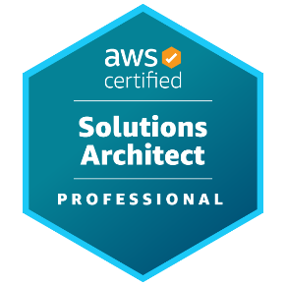
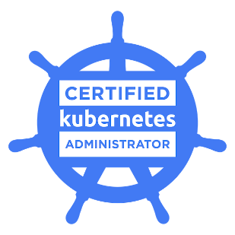
AKHIL REDDY A
Senior Platform Engineer
Phone: +1 (248)-787-9406
Email: akhil.alakanty@gmail.com
Linkedin: https://www.linkedin.com/in/alakantyakhil

R E S U M E O B J E CT I V E

As a senior software Engineer with over 9 years of experience and more than 7 years of experience as a cloud and DevOps engineer, I have implemented and managed complex Cloud DevOps solutions, improving the creation, management, and monitoring solutions to achieve highly available and secure Infrastructure. I leverage my skills and certifications in Kubernetes, AWS, and Azure to configure and manage cloud infrastructure, ensuring high availability, scalability, and security.

CERTIFICATIONS

- AWS Certified Solutions Architect Professional
- Certified Kubernetes Administrator (CKA)

Technical SKILLS

AWS, Azure, GCP, Kubernetes, Helm, OpenShift, Docker, Jenkins, CICD, Git, GitLab, ArgoCD, Terraform, Ansible, Chef, Puppet, DevOps principles, DevSecOps principles, Web development with microservices, Python, Shell, Bash, Groovy scripting, Maven, Ant, Gradle, Splunk, Nagios, Prometheus, Grafana, ELK, Nginx, Apache Tomcat, Node JS, SonarQube, SNYK, Jira, PostgreSQL, MySQL, MongoDB, Cassandra, Angular, Node JS, Java, Kafka, Rabbit MQ, Redis

KPI’s ACHIVED:
- Saved 40% of on-call hours by training a LaMa AI model with current resolved ServiceNow tickets and deploying the model in Teams with a chatbot extension.
- Patched 1000+ AWS EC2 Instances used as EKS(Elastic Kubernetes Service) Nodes with Automated pipelines based on the Linux Distros (BrUpOp for Bottlerocket OS, AWS System Manager > Patch manager for the rest of the Operating systems).
- Developed unified Terraform modules for the Organization to standardize policies for Infra with a Primary focus on security, networking, and cost optimization.
- Achieved 1Hr SLA for Issue/outage resolution for 90% of outages in the Org by standardizing RUN books for support and debugging using DataDog Dashboards and Splunk Logs, which include logs and metrics of the entire Infrastructure.
- Improved security by utilizing tools like Kyverno for Kubernetes policy management to avoid unauthorized application and organization data access.
- Improved Observability by adding 50% more metrics into Datadog by deploying OpenTelemetry and integrating with Datadog.
- Designed cost-effective, highly available hybrid cloud architectures for diverse applications by implementing Blue-Green and Canary deployment strategies, along with robust disaster recovery solutions.

EXPERIENCE
Platform Engineer III / Devops Engineer
Ally Financial, Detroit, USA / April 2024 – present

- Led a 5+ member onshore-offshore team, managing end-to-end sprints and coordinating with the leadership to drive efficient and timely platform deliveries.
- Contributed towards development and optimization of container application platform using AWS public cloud (EKS, ECS, LAMBDA, etc.), Terraform for IAC, Kubernetes Operators (like Kyverno for policy management, ArgoCD, etc.) Aiming towards a Scalable, secure, and highly available architecture.
- Contributed to establishing security standards as part of the architecture, reducing attack surface by implementing the Federated model of account isolation, secrets, and assets.
- Reduced manual provisioning time by 70% and ensured environment consistency across projects by provisioning scalable infrastructure using Terraform and Ansible, enabling platform setup for 6+ Enterprise Data Analytics teams.
- Enhanced system efficiency, minimized latency, and accelerated CI/CD pipeline execution by designing and implementing a robust cache management solution for GitLab Enterprise.
AWS Cloud Engineer / Devops Engineer
Wells Fargo, Texas, USA / July 2023 – March 2024
  - Developed an AWS-based Public cloud platform for 10+ application teams, implementing several AWS services like EKS, EC2, Route53, S3, RDS, Lambda, EFS, S3 Glacier, IAM, CloudFront, CloudWatch, and AWS Load Balancer, prioritizing Auto Scaling and high availability with the help of Terraform and GitHub actions.
  - Secured Infrastuctured access using active directories and IAM services by applying policies like on admin roles and users, ensuring the least privilege.
  - Improved Infra maintenance with a REST API and serverless functions using Node.js on AWS Lambda, SQS, SNS, SES, and API Gateway to create a self-service Platform management tool.
  - Improved Kubernetes Experience for app teams by managing deployment pipelines efficiently and debugging tools by implementing centralized container logging on Splunk and monitoring with CloudWatch, Prometheus, and Grafana, integrated with DataDog.
Cloud Azure DevOps Engineer
CDW Corporation, Illinois, USA / Feb 2021 – Mar 2023
- Architected and deployed scalable Azure cloud infrastructure using ARM templates and Terraform, including Azure Virtual Machines, Azure Blob Storage, and Azure App Service, and leveraged Azure Functions to reduce toil by 50% with self-service portals.
- Reduced deployment errors by 30% by implementing CI/CD with Azure DevOps, automating deployment processes for apps hosted on services such as Azure SQL Database and Azure Kubernetes Service (AKS).
- Improved resource utilization and scalability by optimizing configurations of microservices for Managed Kubernetes clusters on Azure Kubernetes Service (AKS).
- Implemented enhanced observability in system performance to reduce downtime using Azure Monitor, Application Insights, and Prometheus for resources such as Azure Virtual Machines, AKS, and Azure SQL.
MORE EXPERIENCES:
- Role: DevOps Engineer/Site Reliability Engineer (SRE), Company: Sense Electronics / July 2019 – Feb 2021
- Role: Software Engineer, Client: Verizon, Mar 2017 – July 2019
Intellectual Property: (Patent # 451630)
Granted Patent: A 3-DIMENSIONALLY NAVIGABLE DEVICE AND METHOD FOR USE IN AGRICULTURE
Youtube: https://www.youtube.com/watch?v=rQUvQem3eAg

